**Lab Task 1**

Triangle Draw in python:

num_rows = int(input("Enter the number of rows: "));

k = 1

for i in range(0, num_rows):

    for j in range(0, k):

        print("* ", end="")

    k = k + 1

    print()

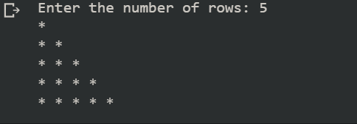

Calculator:

num1 = int(input("Enter 1st number: "))

num2 = int(input("Enter 2nd number: "))

print("1-Sum  2-Product  3-Subtraction 4-Division  5-Modulus  6-Power of num1 with num2   7-Floor division")

n=int(input("Select respective number for operation from above list: "))

if(n==1):

  print("Sum of %d and %d is: " % (num1, num2),num1+num2)

elif(n==2):

  print("Product of %d and %d is: "%(num1,num2),num1*num2)

elif(n==3):

  print("Subtraction of %d and %d is: " %(num1,num2),num1-num2)

elif(n==4):

  print("Division of %d and %d is: " %(num1,num2),num1/num2)

elif(n==5):

  print("Modulus of %d and %d is: " %(num1,num2),num1%num2)

elif(n==6):

  print("Power of %d with %d is: " %(num1,num2),num1**num2)

elif(n==7):

  print("Floor division of %d with %d is: " %(num1,num2),num1//num2)

else:

  print("Enter a valid number.")

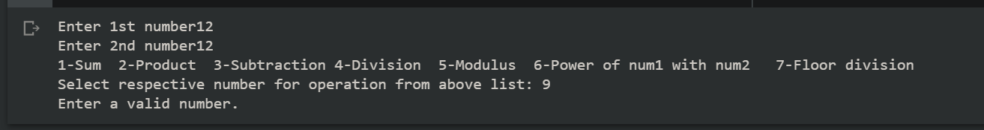

Fibonacci:

n_terms = int(input("How many terms you wants to print? "))

f1 = 0

f2 = 1

count = 0

if n_terms <= 0:

  print ("Please enter a positive integer.")

elif n_terms == 1:

    print ("The Fibonacci sequence up to", n_terms, ": ")

    print(f1)

else:

    print ("The fibonacci sequence is: ")

    while count < n_terms:

        print(f1)

        nth = f1 + f2

        f1 = f2

        f2 = nth

        count += 1

**Lab Task 2**

**Dictionary:**

#dictionary in python

countryCity = {"Pakistan": "Karachi","Turkey": "Istanbul", "Japan": "Tokyo","England": "London"}

print(countryCity)

#inserting element in dictionary

countryCity["Sri Lanka"] = "Colombo"

#updating dictionary

countryCity["Pakistan"] = "Islamabad"

print(countryCity)

#deleting element from dictionary

del countryCity["Japan"]

print(countryCity)

#sorting dictionary elements

sortedList = sorted(countryCity)

print("sorted list is")

print(sortedList)

#getting all only keys of dictionaries

countryCity.keys()

print(countryCity)

#deleting whole dictionary

countryCity.clear();

print(countryCity)

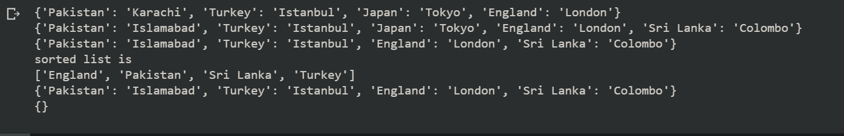

**Taking input in data structures and printing them:**

#implementation of function in python and printing tuple, set, dictionary, list by taking input from users

print("1-Insert in List   2-Insert in Set   3-Insert in Tuple    4-Insert in Dictionary")

choice = int(input("Enter your choice from above: "))

numberOfElements = int(input("Enter number of elements you want to insert: "))

List = ["Apple"]

Tuple = ()

Set = {}

Dictionary = {}

if(choice==1):

  for x in range(numberOfElements):

    element = input("Enter element: ")

    List.append(element)

  print(List)

elif(choice==2):

  for x in range(numberOfElements):

    element = input("Enter element: ")

    Set.add(element)

  print(Set)

elif(choice==3):

  for x in range(numberOfElements):

    element = input("Enter element: ")

    Tuple = Tuple + (element,)

  print(Tuple)

elif(choice==4):

  for x in range(numberOfElements):

    element = input("Enter element: ")

    Dictionary[x] = element

  print(Dictionary)

def printDataStructures():

  if(choice==1):

    print("List is: ", List)

  elif(choice==2):

    print("Set is: " , Set)

  elif(choice==3):

    print("Tuple is: " , Tuple)

  elif(choice==4):

    print("Dictionary is: " , Dictionary)

printDataStructures()

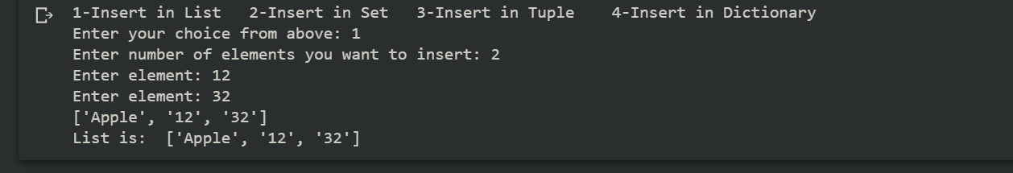

**CRUD operations on All Data Structures:**

**Set:**

#CRUD on set

Set = {0,12,3}

print(Set)

print("1-Insert   2-Delete   3-Update   4-Read")

choice = int(input("Enter your choice: "))

if(choice==1):

  element = int(input("Enter element: "))

  Set.add(element)

  print(Set)

elif(choice==2):

  element = int(input("Enter element you want to delete: "))

  for element in Set:

    if(element):

      Set.discard(element)

  print(Set)

elif(choice==3):

  element = int(input("Enter element you want to update: "))

  new = int(input("Enter new element: "))

  Set.remove(element)

  Set.add(new)

  print(Set)

elif(choice==4):

  element = int(input("Enter element you want to update: "))

  for element in Set:

    print("element found")

  print(Set)

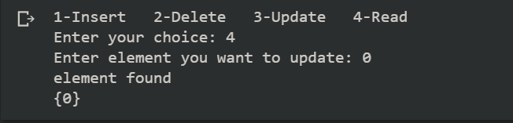

**List:**

#CRUD on List

List = ['ahmad','rehan']

print(List)

print("1-Insert   2-Delete   3-Update   4-Read")

choice = int(input("Enter your choice: "))

if(choice==1):

  element = input("Enter element: ")

  List.append(element)

  print(List)

elif(choice==2):

  element = input("Enter element you want to delete: ")

  List.remove(element)

  print(List)

elif(choice==3):

  element = input("Enter element you want to update: ")

  index = 0

  if element in List:

    index = List.index(element)

  new = input("Enter new element: ")

  List[index] = new

  print(List)

elif(choice==4):

  element = input("Enter element you want to update: ")

  if element in List:

    print("element found")

  print(List)

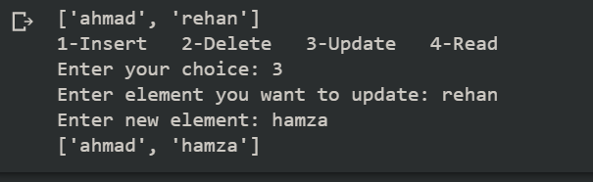

**Dictionary**:

#CRUD on Dictionary

Dictionary = {"England": "London"}

print(Dictionary)

print("1-Insert   2-Delete   3-Update   4-Read")

choice = int(input("Enter your choice: "))

if(choice==1):

  key = input("Enter key: ")

  value = input("Enter value of key: ")

  Dictionary[key] = value

  print(Dictionary)

elif(choice==2):

  key = input("Enter key you want to delete: ")

  del Dictionary[key]

  print(Dictionary)

elif(choice==3):

  key = input("Enter key whose value you want to update: ")

  value = input("Enter new value: ")

  Dictionary[key] = value

  print(Dictionary)

elif(choice==4):

  element = input("Enter key you want to search: ")

  if element in Dictionary:

    print("Element found")

  else:

    print("Element not found - check spellings")

  print(Dictionary)

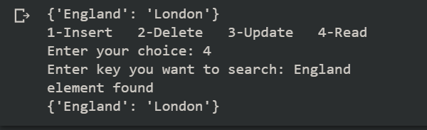

**Tuple**:

**Merging in all Data Structures:**

#merging sets

Set1 = {1,2,3}

Set2 = {4,5,6}

Set3 = Set1.union(Set2)

print(Set3)

#merging Tuples

T1 = (1,2,3)

T2 = (4,5,6)

T3 = T1 + T2

print(T3)

#merging Lists

L1 = [1,2,3]

L2 = [4,5,6]

L1.extend(L2)

print(L1)

#merging Dictionaries

D1 = {1:'ahmad',2:'rashid'}

D2 = {3:'rehan',4:'khan'}

D1.update(D2)

print(D1)

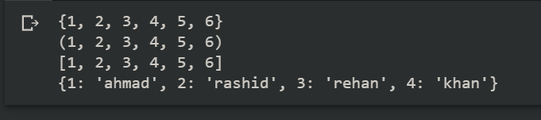

**Lab Task 3**

class Library:

def __init__(self):

self.books = {'Intro to CS': {'Book Name': 'Intro to CS', 'Author Name': 'Ahmad', 'Book ID': '123', 'No of Copies': 3}}

def addBook(self):

name = input("Enter the name of book: ")

author = input("Enter the author of book: ")

id = input("Enter the ISBN of book: ")

copies = int(input('Enter the number of copies: '))

self.books[name] = {'Book Name': name, 'Author Name': author, 'Book ID': id, 'No of Copies': copies}

def removeBook(self):

name = input("Enter the name of book you want to delete: ")

del self.books[name]

def searchBook(self):

name = input("Enter the name of book you want to search: ")

if self.books.get(name):

print('Book found.')

print(self.books[name])

def updateBook(self):

name = input("Enter the name of book you want to update: ")

author = input("Enter the author of book: ")

id = input("Enter the ISBN of book: ")

self.books[name] = {'Book Name': name, 'Author Name': author, 'Book ID': id, 'No of Copies': self.books[name]['No of Copies']}

def viewBooks(self):

print(self.books)

def lendBook(self):

name = input("Enter the name of book you want to lend: ")

print(self.books[name])

if self.books.get(name):

copy = self.books[name]['No of Copies']

copy = copy - 1

self.books[name]['No of Copies'] = copy

print(self.books[name])

def returnBook(self):

name = input("Enter the name of book you want to return: ")

print(self.books[name])

if self.books.get(name):

copy = self.books[name]['No of Copies']

copy = copy + 1

self.books[name]['No of Copies'] = copy

print(self.books[name])

library = Library()

while True:

print('1-Add book 2-Delete book 3-Update book 4-Search book \n5-View all books 6-Lend book 7-Return book')

choice = int(input("Enter your choice: "))

if choice == 1:

library.addBook()

print(books)

elif choice == 2:

library.removeBook()

print(books)

elif choice == 3:

library.updateBook()

print(books)

elif choice == 4:

library.searchBook()

elif choice == 5:

library.viewBooks()

elif choice == 6:

library.lendBook()

print(books)

elif choice == 7:

library.returnBook()

print(books)

else:

break

**Lab Task 4**

graph = {'a':['b','c'],'b':['a','d'],'c':['a','d'],'d':['b','c','e'],'e':['d']}

print(graph)

print('Vertices of graph are: ',list(graph.keys()))

print('Edges of graph are: ', list(graph.values()))

#adding a new vertex

def addVertex():

    vertex = input('Enter vertex: ')

    if(vertex in graph):

        while True:

            edge = input('Enter edge: ')

            graph[vertex].append(edge)

            if(edge in graph):

                    print(edge)

                    graph[edge].append(vertex)

            more = input('Do you want to add more edges(y/n): ')

            if(more=='n'):

                break

    else:

        graph[vertex] = []

        while True:

            edge = input('Enter edge: ')

            graph[vertex].append(edge)

            if(edge in graph):

                print(edge)

                graph[edge].append(vertex)

            more = input('Do you want to add more edges(y/n): ')

            if(more=='n'):

                break

    print(graph)

#DFS traversal

def DFS(graph, start, visited=None):

    if visited is None:

        visited = set()

    visited.add(start)

    print(str(start) + " ", end="")

    for x in graph[start]:

        if x not in visited:

            DFS(graph, x, visited)

#BFS traversal

from collections import deque

def BFS(graph, start):

    visited = set()

    queue = deque([start])

    visited.add(start)

    while queue:

        vertex = queue.popleft()

        print(str(vertex) + " ", end="")

        for neighbor in graph[vertex]:

            if neighbor not in visited:

                visited.add(neighbor)

                queue.append(neighbor)

print('DFS traversal is: ')

DFS(graph,'a')

print('\nBFS traversal is: ')

BFS(graph,'a')

